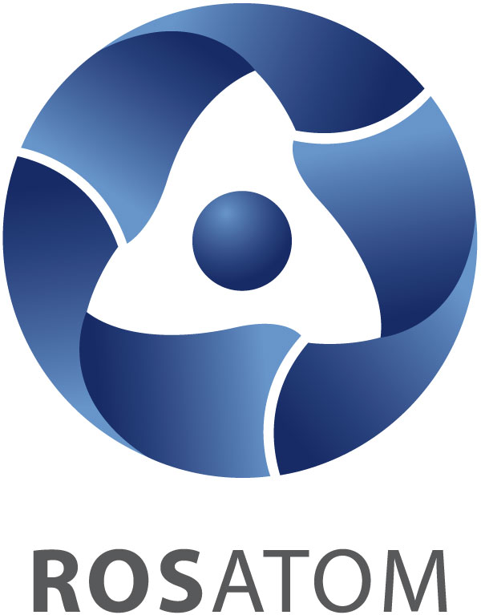
INTERNATIONAL FORUM
ATOMEXPO 2014

Moscow • June 9 - 11 2014 • Gostiny Dvor

CONGRESS PROGRAM

Monday, JUNE 9, 2014 – plenary session, round tables, symposium
Tuesday, JUNE 10 2014 – round tables
Wednesday, JUNE 11 2014 – round tables

PLENARY SESSION PROGRAM
JUNE 9

Topic: «Nuclear energy» - condition for energy stability»
15.00-17.30 | PLENARY SESSION | Conference-hall №1

Moderator: Luis Echávarri, ex-director General, OECD Nuclear Energy Agency (France).
Speakers:

- Sergey Kirienko, Director General, ROSATOM (Russia);
- Luc Oursel, Chief Executive Officer, Areva (France);
- Agneta Rising, Director General of the World Nuclear Association;
- Alexander Bychkov, Deputy Director General, IAEA;
- Takuya Hattori, President, JAIF, Japan;
- Le Duong Quang – Deputy Minister of Industry and Trade of the Socialist Republic of Vietnam;
- Zafer Alper, President of the Turkish Atomic Energy Authority;
- Minna Forsström, Project Director, Fennovoima.

