Contact person: |  | Date:
Company Name: |  | Phone:
E-mail: |  | Fax:
Please reserve a room at the Metropol Hotel for the following person:

First Name / ______________________________ Last Name / __________________________________
Arrival date / _____________________________ Departure date / ________________________________
Gender (Sex) F □ / M □

Room | Single occupancy | Double occupancy
□ Standard | 9 322 | -----------------
□ Standard double | 10 502 | 11 682
□ Superior | 11 682 | 12 862
□ Junior suite | 17 582 | 18 762
□ Executive suite | 29 382 | 30 562
□ Grand Metropol suite | 48 970 | 50 150
(Rates are indicated in Russian Rubles. Special rates include full buffet breakfast at the “Metropol” restaurant, 18% VAT, free Wi-Fi, complimentary use of health club, coffee and tea-making facilities)

Please guarantee this reservation by a credit card:
Credit Card No _________________________________ Validity ______________________________________
Credit Card Holder’s name ________________________ Signature_____________________________________

◻ Please send me invoice for 100% pre-payment. Advanced payment has to be made not later than 06th of June, 2014.
◻ Please take my Credit Card as a guarantee and charge for this reservation
Reservation and cancellation policy:
Special rates are valid till June 06, 2014 and only for the dates of the conferences. Room availability and rates for pre- and post-stay days should be checked separately. Reservation form has to be completed by each guest and sent back to Hotel not later than June 06, 2014. All requests made after June 06, 2014 will be confirmed only upon availability and at best available rates. Non-guaranteed reservations will not be accepted. Please forward your reservations as early as possible to ensure your choice.
Reservation must be canceled 48 hours prior (06/06/2014) to arrival to avoid billing of one night’s room and tax. The hotel reserves the rights to charge 100% of the room rate for the first night as a guarantee in case of a late changes and cancellation, no-show or visa support.

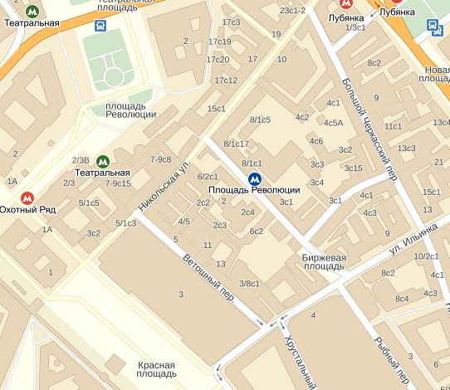


Signature, printed last name and title

Distance from Metropol Hotel to Gostiniy Dvor is 600 meters; 10 minutes of walking.

